1. Rube Goldberg was an artist who drew cartoons that showed a very complicated way to do a simple task. The picture below shows a cartoon like the ones Goldberg drew.

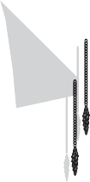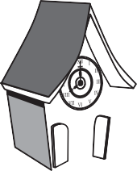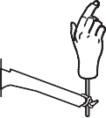

### How to Turn On a Light Switch the Rube Goldberg Way

1. The bird in the clock hits the ball.
2. The ball rolls down the ramp.
3. The ball falls into the balance pan.
4. The balance pan moves down.
5. The hand moves up.
6. The switch turns on.

Which form of energy is used to turn on the switch?

1. Light energy
2. Thermal energy
3. Electrical energy

**J** Mechanical energy

1. Some facts about birds called cattle egrets are listed below.

### Cattle Egrets

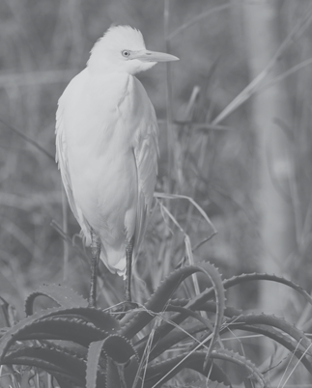

1. They have yellow bills and light-orange legs.
2. They make nests in trees away from predators.
3. They eat ticks off cattle while the cattle graze.
4. They are often found in the same fields as cattle.

Which of these facts best describes how these birds depend on other animals to survive?

© Nicolaas Trout/ iStockphoto # 6958570

1. Fact 1
2. Fact 2
3. Fact 3
4. Fact 4
5. Which alternative energy source is generated beneath Earth’s crust and can be used to heat buildings?
6. Hydroelectric energy
7. Geothermal energy
8. Wind energy
9. Solar energy
10. The picture below shows a child standing in a swimming pool.

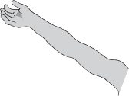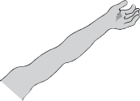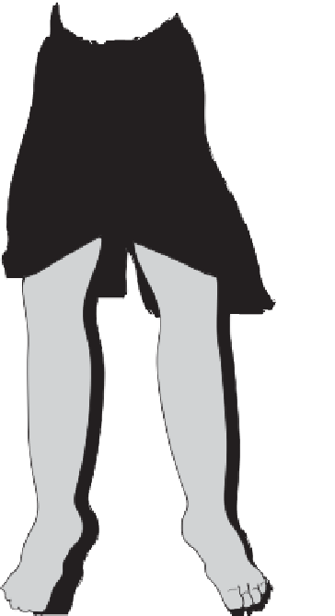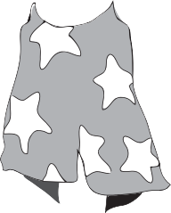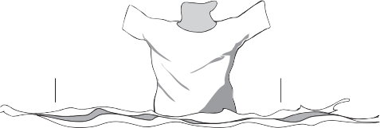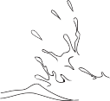

Why does the lower part of the child appear so much different in size from the upper part?

**F** The light rays that travel through water and then into air are refracted. **G** The light rays that travel through water and then into air are enlarged. **H** The light rays that travel through air and then into water are reflected. **J** The light rays that travel through air and then into water are reduced.

1. Which of the methods of generating electricity shown below does **NOT** use alternative energy resources?

#### H

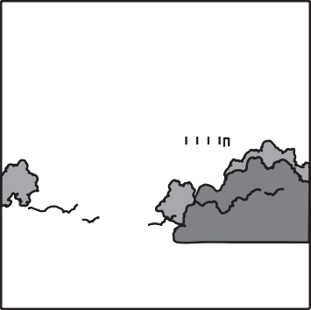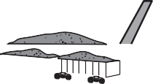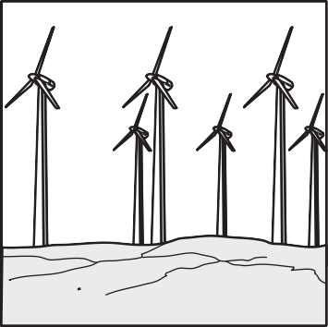

1. **J**
2. A class is learning about states of matter. The teacher shows the students how to set up the investigation shown in the diagram.

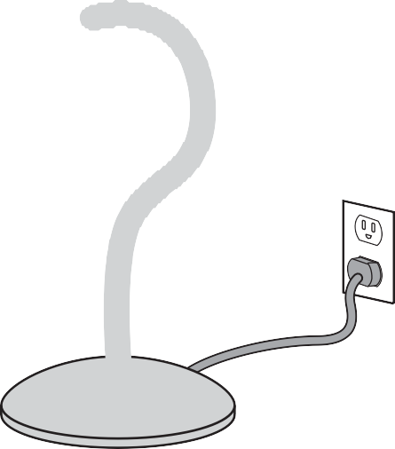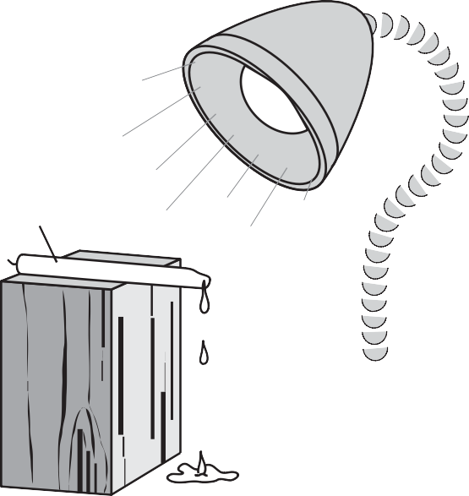

Candle

Wood block

What kinds of energy are needed in this investigation to change the state of matter of the candle?

1. Light, mechanical, and thermal
2. Electrical and thermal
3. Mechanical, light, and electrical
4. Thermal and mechanical